Youth Council Attendance Process Documentation

This is documentation on the attendance-taking process using the updated website. The Wix site also has good documentation for this process linked here: https://support.wix.com/en/article/check-in-by-wix-checking-in-guests-to-an-event?tabs=Check-in-app

- Take attendance
  - The attendance can either be taken on paper and then input into the Wix Check-In app, or just directly taken in the Wix Check-In app (or directly taken in the Wix site dashboard)
  - To take attendance with the app (which is recommended), the secretary/officer taking attendance will need to download and log in to the Wix Check-In app (seen below)

  - After logging in, the user should see a dashboard with all the upcoming events: 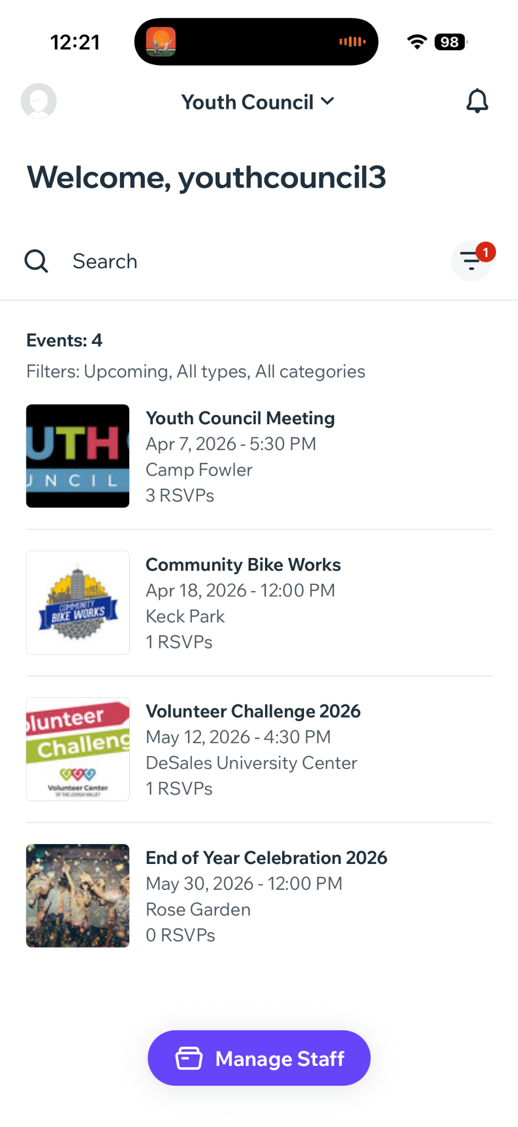
  - Then, click on the individual event you wish to take attendance for, which will take you to a page similar to:
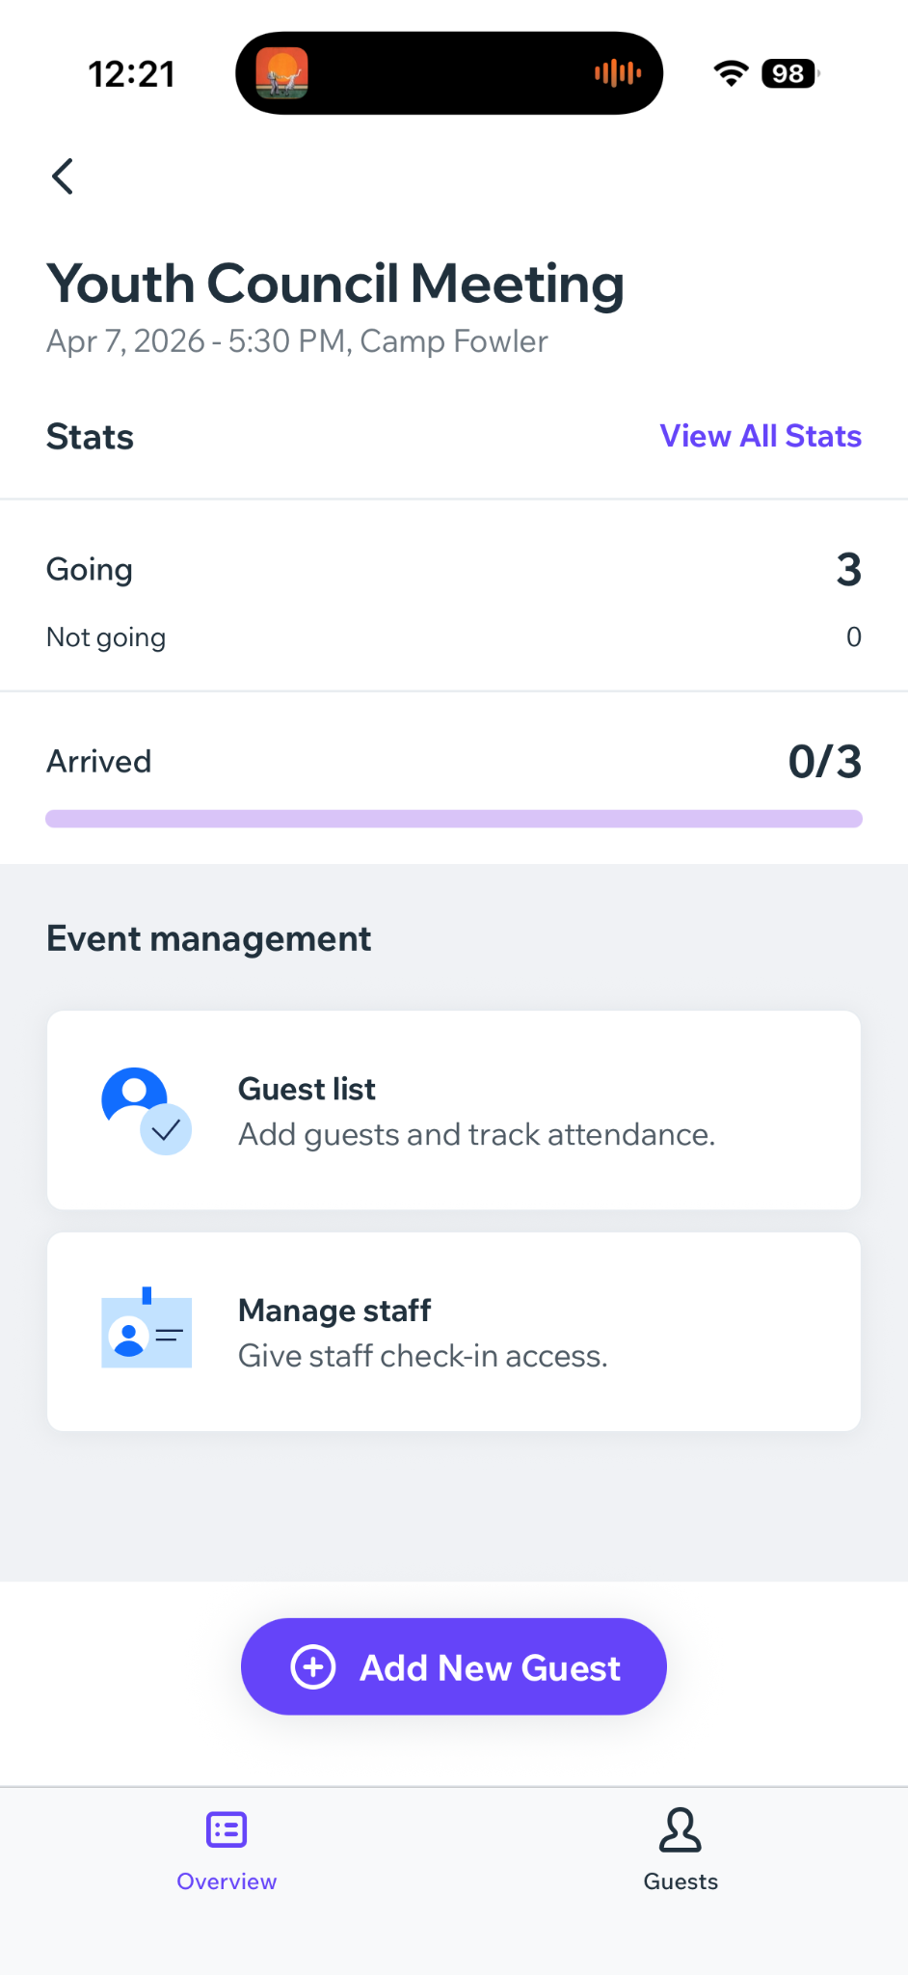

  - Click on the “Guest List” tab, which will take you to:
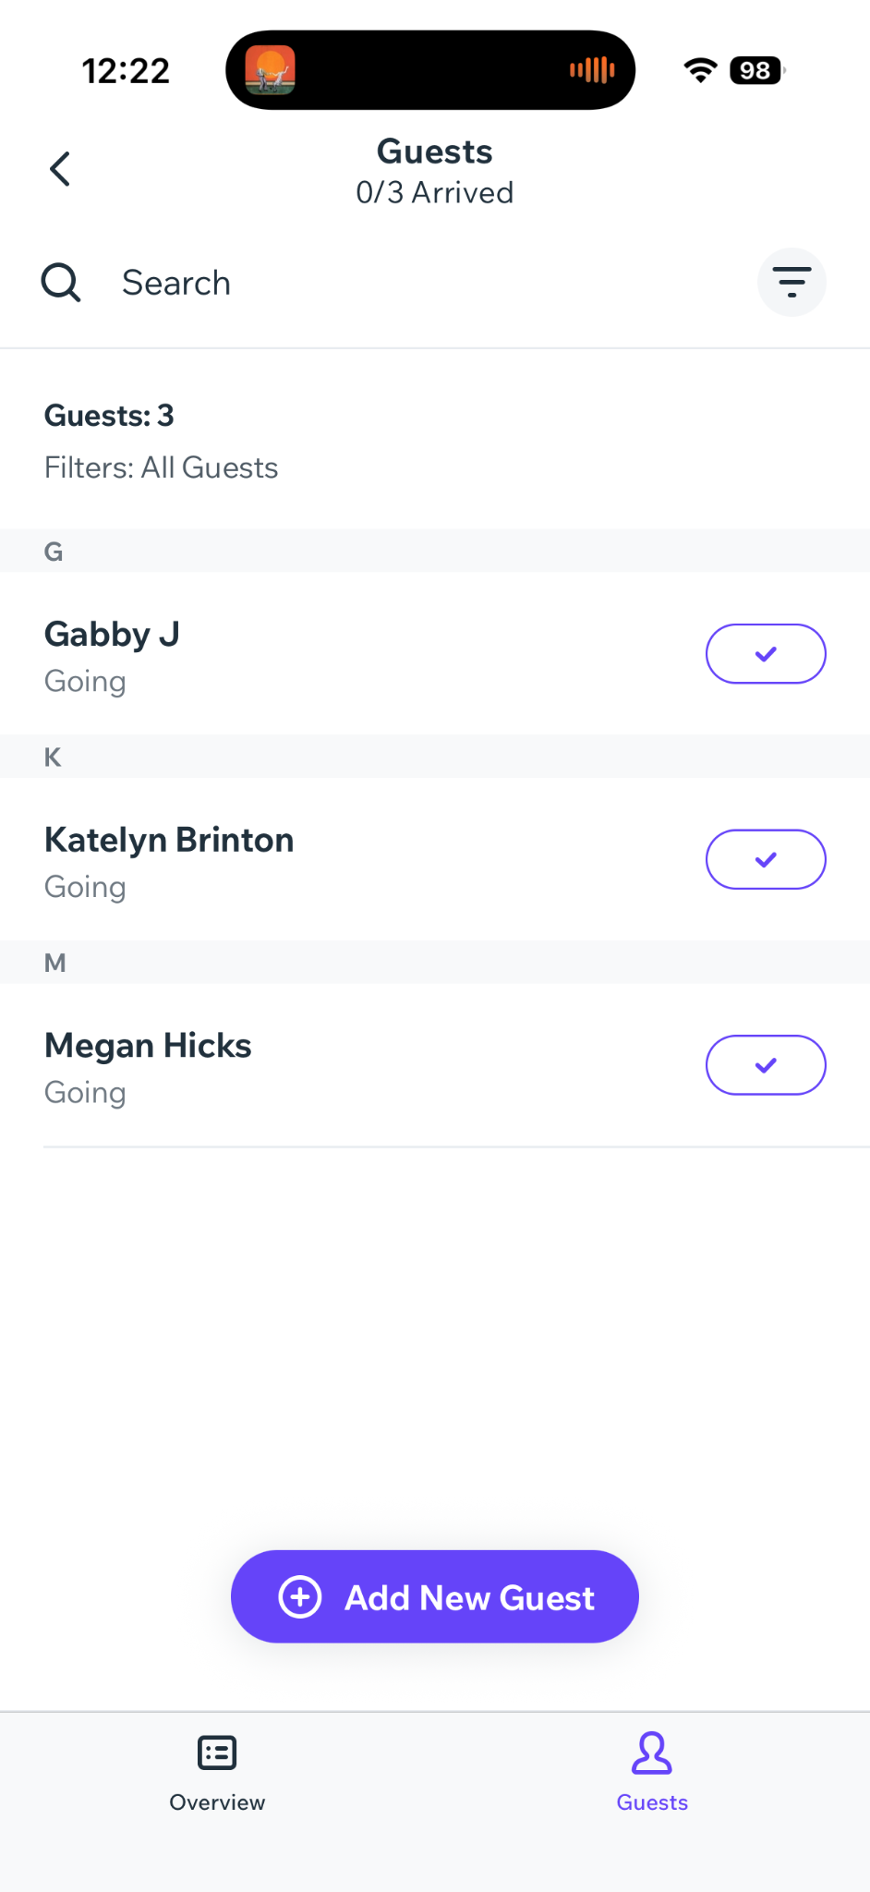
Guest 1

  - Then, the user can click the white check box (turning it purple) to confirm that the member came to the event
  - If a guest or member who didn’t RSVP comes to the event, the user can add them using the “Add New Guest” button

- Seeing & Exporting attendance on the site Dashboard
  - Log in and navigate to the Wix dashboard and to the published events page located here:
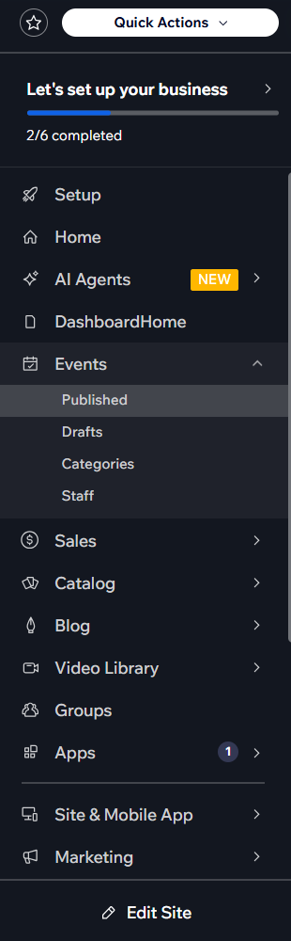

  - You will then see this dashboard with all the published events, and click the one you wish to see using the “Manage” button:
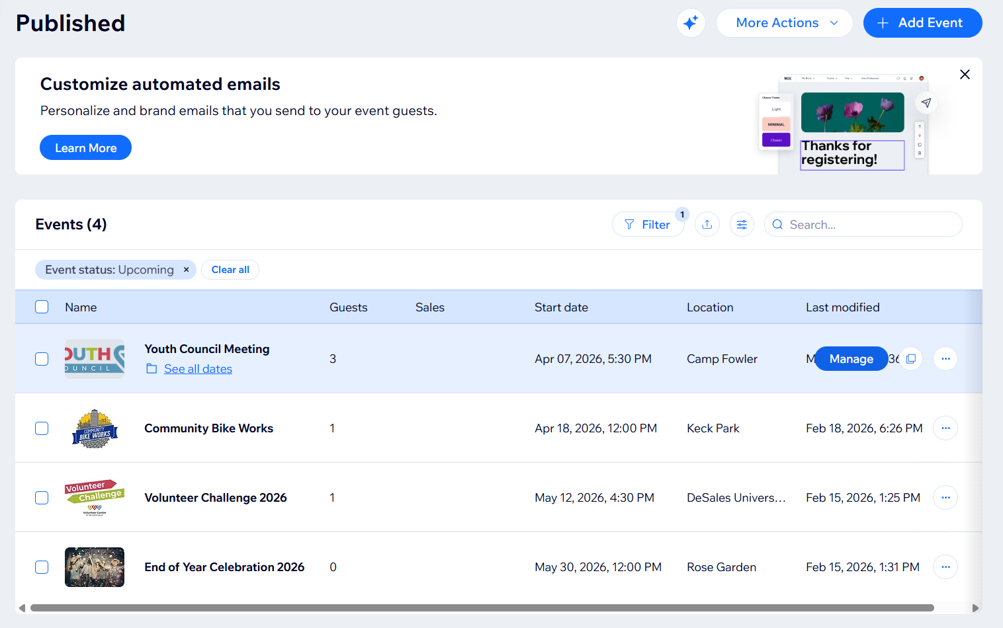

  - Then, navigate to the “Guests” page to see all the RSVP’d guests. There, you can see each guest and whether they were checked in to the event. You can also add guests and export the guest data into a CSV.

